Problem Set 1

1. Here are the summary statistics for various (n,p):
   1. For (30, 0.05), the mean estimate of p is 0.0523, the mean estimate of the true standard deviation is 0.192, and the coverage rate is 0.801.
   2. For (30, 0.25), the mean estimate of p is 0.2512, the mean estimate of the true standard deviation is 0.424, and the coverage rate is 0.944.
   3. For (60, 0.05), the mean estimate of p is 0.0506, the mean estimate of the true standard deviation is 0.207, and the coverage rate is 0.8.
   4. For (60, 0.25), the mean estimate of p is 0.2495, the mean estimate of the true standard deviation is 0.428, and the coverage rate is 0.942.

I do agree that n of 30 or larger is enough to ensure that the asymptotic confidence intervals work well, as we can see in the case of (n,p) = (30, 0.25) and (60, 0.25). However, we also need p to not be close to 0 or 1, or else the confidence intervals break down. We can see in the case of (30, 0.05) and (60, 0.05) that the coverage rate is not close to 95% as expected.

1. 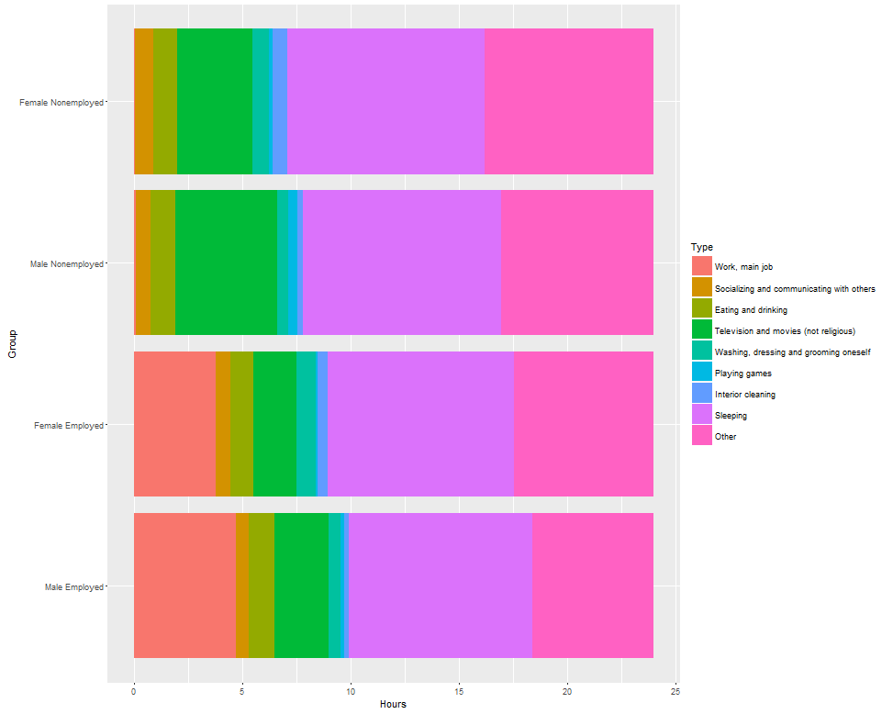

Some common trends are that men work for more hours, watch slightly more TV and movies, and play more games than women; nonemployed people spend slightly more time sleeping, socializing and watching television and movies than employed people. Lastly, females spend more time doing other things than males, likely taking care of family members or taking care of the house.